**RFbee V1.1 - Wireless arduino compatible node**

窗体顶端

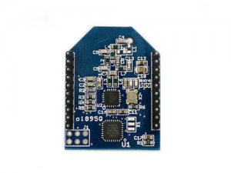

http://www.seeedstudio.com/depot/includes/templates/pure_green/images/next_l.gif

* [http://www.seeedstudio.com/depot/bmz_cache/d/d8fa52d9726cc0b231f853eac0c230fd.image.55x41.jpg](http://www.seeedstudio.com/depot/images/rfbee1.jpg)
* [http://www.seeedstudio.com/depot/bmz_cache/6/683fb4d876c49dc0f736c5dea8c352a2.image.55x41.jpg](http://www.seeedstudio.com/depot/images/rfbee1_01.jpg)

http://www.seeedstudio.com/depot/includes/templates/pure_green/images/next_r.gif

* **Price:**

$19.50  [(Price Feedback)](javascript:void())

* **SKU:**

WLS126E1P

* **Weight:**

3Gram

* **Units in Stock**

47

* **Designed by:**

[Seeed Studio](http://www.seeedstudio.com/)



[Other products from designer](http://www.seeedstudio.com/depot/seeed-studio-m-23.html)

* **Quantity:** Max: 47  
  
* [Add to Wish List](http://www.seeedstudio.com/depot/index.php?main_page=un_wishlist&products_id=614&cPath=139_140&action=un_add_wishlist)

Description

**Due to New Year Holidays new orders are going to be processed after Jan 3, 2013**

The RFBee is a RF module providing easy and flexible wireless data transmission between devices. It is based on a AVR Atmega168 working as a fully functional Arduino connected via SPI to a TI CC1101 RF transceiver.

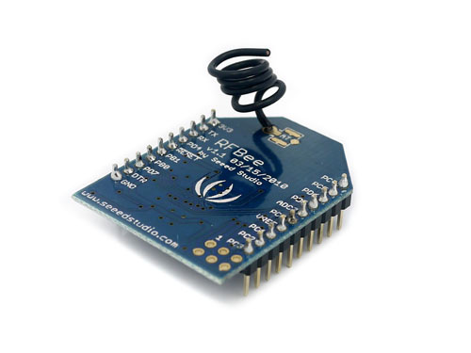

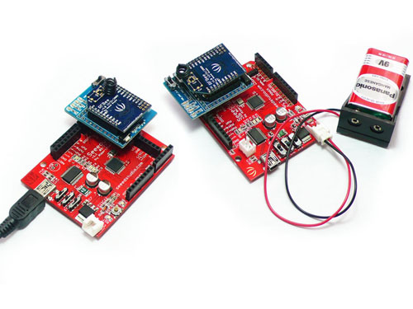

**Features**

* Range: indoor/Urban: up to 50m; Outdoor line-of-sight: up to 120m;
* Receiver sensitivity: -95dBm
* RF data transmission rate: 4,800bps; 76,800bps
* Working frequency : 868MHz & 915MHz
* Communication type: Point to Point, or Point to Multipoint.
* Easy-to-Use serial interface and rich extendable ports
* Easy-to-Use AT command: Set working mode, Serial Baud Rate, etc.
* Open source hardware and firmware
* Socket compatible with the Xbee, so you can plug it into any Xbee socket as a quick replacement.

**Note:**

only the Rx,Tx, VCC, GND pins are identical to the Xbee. RFbee will not communicate with Xbee, so RFbee need to be used on both ends of the wireless connection.

**Documents**

Please visit our[wiki page](http://garden.seeedstudio.com/index.php?title=RFbee_V1.1_-_Wireless_Arduino_compatible_node) for more info about this product. It will be appreciated if you can help us improve the documents, add more demo code or tutorials. For technical support, please post your questions to our [forum](http://www.seeedstudio.com/forum).

窗体底端